22.24: a) Positive charge is attracted to the inner surface of the conductor by the charge in the cavity. Its magnitude is the same as the cavity charge: 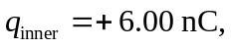 since 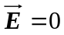 inside a conductor.
b) On the outer surface the charge is a combination of the net charge on the conductor and the charge “left behind” when the 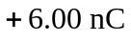 moved to the inner surface:

